**Azure Traffic Manager**

Azure Load balancer is DNS based traffic load balancer that enables you to distribute traffic optimally to service across global azure region, while providing high availability and responsiveness

Azure load balancer work on specific region and work on public ip and private ip

Traffic manger works across region

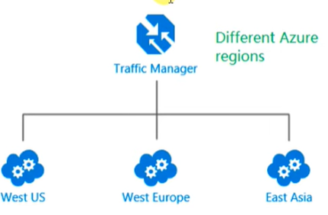

**Feature:**

* **Increase application availability:** monitoring your endpoints and providing automatic failover when an endpoint goes down.
* **Improve application performance**: Traffic Manager can improve the responsiveness of your website by directing traffic to the endpoint with the lowest latency.
* **Perform service maintenance without down time**: Traffic Manager can direct traffic to alternative endpoints while the maintenance is in progress.
* **Combine hybrid application**: Traffic Manager supports external, non-Azure endpoints enabling it to be used with hybrid cloud
* **Distribute traffic for complex deployment**

**Routing Method:**

**Priority:** when we want to use primary service endpoint for all the traffic and provide backups in case the primary or backup endpoints are unavailable

**Weighted:** when we want to distribute traffic across set of endpoints, either evenly or according to the weight

**Performance:** when we have endpoints in different geographic location and you want end user to use the closest end point in term of latency

**Geographic:** it routes traffic to specific node based on source location

**Multi value:** It allows you to get multiple healthy endpoints in single DNS query response.

**Subnet:** it routes traffic to specific node based on source IP address range